javaScript Code Step

Objective:

It is used to execute any custom external javascript code. Scripts are provided and executed as plain text. They don’t need special preparation or compilation to run. In this aspect, JavaScript is very different from another language called java.

## UI

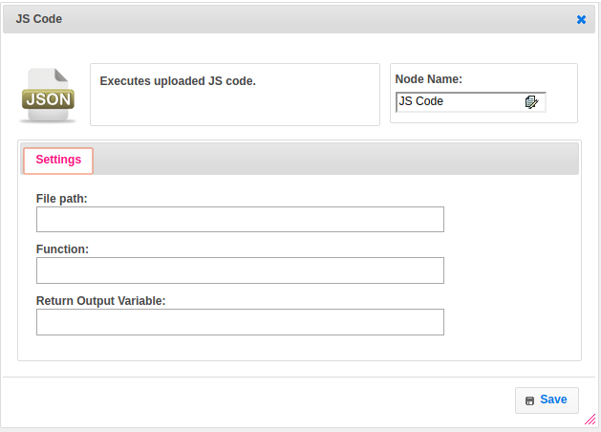

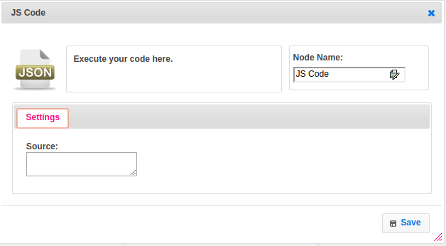

## Attributes:

|  |  |
| --- | --- |
| **Attributes** | **Description** |
| Source | The source code which user want to execute directly in javascript |
| Function | The name of function from the source file path to execute the code |
| Return Output Variable | Used to store the response of the step |
| File Path | To get the source file path which presents in the appup_lib folder |

## Executor Description:

In executor class if inline is true execute code directly with src, the inline code should return map object into which you can insert new keys and remove the existing keys. If returned value is not map then set that value to Map, where the key name is the function_name. Function should return the map object so that it will be usable in further steps.

## Resource:

For more information please refer the below link

<https://documentation.js.org/>